**A PROJECT REPORT**

**on**

**“Ride Dekho”**

**Submitted to**

**KIIT Deemed to be University**

**In Partial Fulfillment of the Requirement for the Award of**

**BACHELOR’S DEGREE IN**

**COMPUTER SCIENCE AND ENGINEERING**

**BY**

**ROSHAN BARIK 2005186**

**SOMALI KUNDU 2005203**

**SAMEER SHEKHAR 2005960**

**SRISHTY SINGH 2006972**

**UNDER THE GUIDANCE OF**

**Dr. PARTHA SARATHI PAUL**



**SCHOOL OF COMPUTER ENGINEERING**

**KALINGA INSTITUTE OF INDUSTRIAL TECHNOLOGY**

**BHUBANESWAR, ODISHA-751024**

**May-2024**

**KIIT Deemed to be University**

School of Computer Engineering

Bhubaneswar, Odisha-751024



**CERTIFICATE**

This is to certify that the project entitled

“Ride Dekho”

Submitted by

ROSHAN BARIK 2005186

SOMALI KUNDU 2005203

SAMEER SHEKHAR 2005960

SRISHTY SINGH 2006972

is a record of bonafide work carried out by them, in the partial fulfillment of the requirement for the award of Degree of Bachelor of Engineering (Computer Science & Engineering) at KIIT Deemed to be university, Bhubaneswar. This work is done during year 2022-2023, under our guidance.

Date: 05/05/2023

(Guide Name)

Project Guide

**ACKNOWLEDGEMENT**

We are profoundly grateful to **DR.PARTHA SARATHI PAUL** of **Affiliation** for his expert guidance and continuous encouragement throughout to see that this project rights its target since its commencement to its completion.

I extend my sincere thanks to Dean CSE for providing excellent platform and

resources to carry out my research projects. Also I would like to thank the panel

members for their valuable suggestions and support during presentation of my

research projects.

I thank my friends, fellow researchers and family members who have encouraged me in my research efforts and shouldered me in needy times.

ROSHAN BARIK

SOMALI KUNDU

SAMEER SHEKHAR

SRISHTY SINGH

**ABSTRACT**

The Car and Bike Rental System is being developed for customers so that they can book their cars and bikes from any part of the world. This application takes information from the customers through filling in their details.

A customer being registered on the website has the facility to book a car or a bike which he requires. The proposed system is completely integrated with online systems. It automates manual procedures in an effective and efficient way. This automated system facilitates customers and allows them to fill up the details according to their requirements. It includes the type of car or bike they are trying to hire and location. The purpose of this system is to develop a web site for people who can book their car and bike along with requirements from any part of the world. The car and bike rental system provides a car or bike to users at their location in a short time.

**TABLE OF CONTENT**

**CHAPTER PAGE NO.**

ABSTRACT

LIST OF TABLE

LIST OF FIGURE

**1. Introduction**

1.1 Introduction to online car and bike rental system....................................................9

1.2 Reason for Project....................................................................................................9

1.3 Problem Statement.................................................................................................10

1.4 Aims & Objective ..................................................................................................10

1.5 Scope......................................................................................................................10

1.6 Summary................................................................................................................11

**2. Online Car and Bike Rental System**

2.1 How Car and Bike rental services work................................................................12

2.2 Benefits of Online Car and Bike Rental System ..................................................12

**3. Requirement Analysis**

3.1 Introduction............................................................................................................13

3.2 Feasibility Study ...................................................................................................13

3.2.1 Technical Feasibility .........................................................................13-14

3.2.2 Operational Feasibility ...........................................................................14

3.2.3 Economical Feasibility............................................................................14

3.2.4 Legal Feasibility......................................................................................15

3.3 System Implementation .........................................................................................15

3.4 Functional Requirement ........................................................................................15

3.5 Non- Functional Requirement................................................................................16

3.6 Hardware & Software Requirement..................................................................16-17

**4. Existing System**

4.1 Introduction............................................................................................................18

4.2 Problem statement.............................................................................................18-19

**5. Proposed System**

5.1 Introduction............................................................................................................20

5.2 Advantage .............................................................................................................20

5.3 Specification of Proposed system ....................................................................21-22

**6. System Architecture design**

6.1 Data Flow Diagram...........................................................................................23-25

6.2 ER-Diagram ..........................................................................................................26

**7. Use-Case Diagram**

7.1 Use case description..........................................................................................27-28

7.2 Use case Login.......................................................................................................28

7.3 Use case booking ...................................................................................................29

7.4 Use case viewing....................................................................................................30

7.5 Use case Diagram ..................................................................................................31

**8. Output/Screenshot**

8.1 Screenshot.........................................................................................................32-35

8.2 Summary ...............................................................................................................36

**9. Conclusion & Future Enhancement**

9.1 Conclusion .............................................................................................................37

9.2 Future Enhancement ..............................................................................................37

**10. Bibliography & References**

10. ................................................................................................................................38

**LIST OF TABLE**

**TABLE 1**: Actors & Use-case Description .......................................................................27-28

**TABLE 2:** Use-Case Login.....................................................................................................28

**TABLE 3**: Use-Case Booking Car and Bike...........................................................................29

**TABLE 4**: Use Case View my Booking ................................................................................30

**LIST OF FIGURE**

**FIGURE 1**: Zero Level DFD .................................................................................................23

**FIGURE 2:** First Level DFD ..................................................................................................24

**FIGURE 3**: Second Level DFD..............................................................................................25

**FIGURE 4**: ER-Diagram .......................................................................................................26

**FIGURE 5:** Online car and bike rental system Use-case ...................................................…31

**FIGURE 6**: Home page...........................................................................................................32

**FIGURE 7**: Login page ..........................................................................................................33

**FIGURE 8:** Car listing............................................................................................................34

**FIGURE 9**: Contact-us page ..................................................................................................34

**FIGURE 10**: Booking page ....................................................................................................35

**FIGURE 11:** Booking Succesfully page.................................................................................35

**CHAPTER-1**

**INTRODUCTION**

**1.1 Introduction to online car and bike rental system**

This project is designed so as to be used by a Car and Bike Rental company specializing in renting cars to customers. It is an online system through which customers can view available cars and bikes, register, view profile and book cars and bikes. Here, users have to Login to book a car or a bike. The user can search for cars and bikes easily and book. For bookings, the user has to provide information such as booking dates and text messages. All car and bike details are provided and it also includes the car’s and bike’s features and overview. The user can also post their testimonials and the user can update their profile as well as passwords anytime they want from the site. Admins can Add/Manage car and bike brands, manage cars and bikes, bookings, testimonials, pages and many more. It’s easy to operate and be understood by users. This site makes customers easy for car and bike rental. The design is pretty simple and the user won’t find it difficult to understand, use and navigate.

**1.2 Reason for the Project**

➢ **Enhance Business Processes**: To be able to use internet technology to

project the rental company to the global world instead of limiting their

services to their local domain alone, thus increasing their return on

investment (ROI).

➢ **Online Car and Bike Reservation**: A tool through which customers can book available cars and bikes online prior to their expected pick-up date or time.

➢ **Customer’s registration**: A registration portal to hold customer’s details, monitor their transactions and use same to offer better and improved services to them.

➢ **Group Booking/Event Management**: Allows the customer to book space for a group in the case of weddings or corporate meetings

**1.3 Problem Statement**

A car and bike rental is a car or bike that can be used temporarily for a fee during a specified period. Getting a rental car or bike helps people get around despite the fact they do not have access to their own personal car or bike or don't own a car or bike at all. The individual who needs a car or bike, must contact a rental company and contract out for a car or a bike. This

system increases customer retention and simplifies car or bike and staff management.

**1.4 Aims & Objective**

➢ To produce a web-based system that allows customers to register and

book a car or a bike online and for the company to effectively manage their car and bike rental business.

➢ To ease the customer’s task whenever they need to rent a car or a bike.

**1.5 Scope**

This project traverses a lot of areas, ranging from business concepts to the computing field, and requires us to perform much research to be able to achieve the project objectives.

The area covered includes:

➢ **Car and Bike rental industry**: This includes a study on how the car and bike rental business is being done, process involved and opportunities that exist for improvement.

➢ PHP Technology is used for the development of the application.

➢ General customers as well as the company’s staff will be able to use the system effectively.

➢ Web-platform means that the system will be available for access 24/7

except when there is a temporary server issue which is expected to be

minimal.

**1.6 Summary**

The main objective of this Car and Bike Rental System project will enable users to rent a car or a bike. The user shall login to the system and check for availability of cars and bikes. The user specifies the type of car and bike and the journey date and time. The Car and Bike Rental System will check for the availability of the car and bike and rent the car or the bike to the customer. All the data regarding the rental cars and bikes is stored in a MySQL database. The user has to enter his name, address, phone details and check for the cars and bikes available for rent. The UI is very simple and the connectivity to back end is robust. The main advantage is that the user will be able to choose a car or bike depending on his budget.

**CHAPTER-2**

**ONLINE CAR AND BIKE RENTAL SYSTEM**

**2.1 How Car and Bike Rental Services Work**

A car and bike rental is a car and bike that can be used temporarily for a period of time for a fee. Renting a car or bike assists people with getting around even when they do not have access to their own personal vehicle or don't own a car or bike at all. An individual who wants to rent a car or a bike must first contact the car and bike rental company for the desired car or bike. This can be done

online. At this point, this person has to supply some information such as dates of rental, and type of car or bike, fuel type, etc. After these details are worked out, the individual renting the car must present a valid Identification Card(Aadhar Card, Passport) during handling the car or the bike. Most companies throughout the industry make a profit based on the type of cars or bikes that are rented. Rental cars and bikes are provided of every type. And customers are free to choose any car or bike of their choice based

on their purpose and availability of such a car or bike at the time of reservation.

**2.2 Benefits of Online Car and Bike Rental Services**

➢ This online car and bike rental solution is fully functional and flexible.

➢ It is very easy to use.

➢ It saves a lot of time, money and labour.

➢ Eco-friendly: The monitoring of the car activity and the overall business becomes easy and includes the least of paper work.

➢ The software acts as an office that is open 24/7.

➢ It increases the efficiency of the management in offering quality

services to the customer.

**CHAPTER-3**

**REQUIREMENT ANALYSIS**

**3.1 Introduction**

Here we will be discussing the requirements of making this application

possible and respond as we wanted it to . This is only done through the thinking of the developer as well as the vision provided by our guide, Mr. Partha Sarathi Paul.

In this we will also understand the platform on which our application is

running and on which it is being developed.

**3.2 Feasibility Study**

The preliminary investigation examines project feasibility, the likelihood of the system will be useful to the organization. The main objective of the feasibility study is to test the Technical, Operational and Economical feasibility for adding new modules and debugging old running systems. All systems is feasible if they are unlimited resources and infinite time. There are aspects in the feasibility study portion of the preliminary investigation:

➢ Technical Feasibility

➢ Operation Feasibility

➢ Economical Feasibility

**3.2.1 Technical Feasibility**

➢ The technical issue is usually raised during the feasibility stage of the

investigation includes the following:

➢ Does the proposed equipment have the technical capacity to hold the data required to use the new system?

➢ Will the proposed system provide adequate response to inquiries, regardless of the number or location of users?

➢ Are there technical guarantees of accuracy, reliability, ease of access and data security?

**3.2.2 Operational Feasibility**

Proposed projects are beneficial only if they can be turned into information

system. That will meet the organization’s operating requirements. Operational

feasibility aspects of the project are to be taken as an important part of the project implementation. Some of the important issues raised are testing the operational feasibility of a project that includes the following: -

➢ Is there sufficient support for the management from the users?

➢ Will the system be used and work properly if it is being developed and

implemented?

➢ Will there be any resistance from the user that will undermine the possible application benefits?

**3.2.3 Economical Feasibility**

A system can be developed technically and that will be used if installed must still be a good investment for the organization. In the economical feasibility, the

development cost in creating the system is evaluated against the ultimate benefit

derived from the new systems. Financial benefits must equal or exceed the costs.

**3.2.4 Legal Feasibility**

In the legal feasibility, it is necessary to check that the software we are going to

develop is legally correct, which means that the ideas which we have taken for

the proposed system will be legally implemented or not, so it is also an important step in the feasibility study.

**3.3 System Implementation**

During the implementation stage, the stage is physically created.

Necessary programs are coded, debugged and documented. A new hardware is

selected , ordered and installed.

**3.4 Functional Requirements**

Requirement analysis is a software engineering technique that is composed of the various tasks that determine the needs or conditions that are to be met for a new or altered product, taking into consideration the possible conflicting requirements of the various users.

Functional requirements are those requirements that are used to illustrate the

internal working nature of the system, the description of the system, and

explanation of each subsystem. It consists of what task the system should

perform, the processes involved, which data should the system holds and the

interfaces with the user. The functional requirements identified are:

➢ **Customer’s registration:** The system should allow new users to register online and generate a membership card

➢ **Online reservation of cars**: Customers should be able to use the system to make booking and online reservations.

➢ **Automatic update to database once reservation is made or new**

**customer registered**: Whenever there’s a new reservation or new

registration, the system should be able to update the database without any

additional efforts from the admin.

**3.5 Non-Functional Requirements**

It describes aspects of the system that are concerned with how the system

provides the functional requirements.

They are:

➢ **Security:** The subsystem should provide a high level of security and

integrity of the data held by the system, only authorized personnel of the company can gain access to the company’s secured page on the system and only users with a valid password and username can login to view user’s page.

➢ **Availability**: This system should always be available for access at 24

hours, 7 days a week. Also, in the occurrence of any major system

malfunctioning, the system should be available in 1 to 2 working days, so

that the business process is not severely affected.

➢ **Ease of use:** Considering the level of knowledge possessed by the users of this system, a simple but quality user interface should be developed to make it easy to understand and require less training.

**3.6 Hardware and Software Requirement**

**Hardware Requirements:**

Processor : Intel Pentium Dual Core

RAM : 512 MB

Hard Disk : 160 GB Space

**Software Requirements:**

Operating System : Windows /iOS/Unix17

Web Browser : IE/Google Chrome/Firefox

Technology : PHP

Tools : XAMPP

Web Design : HTML, CSS, JAVASCRIPT

Back End : MYSQL

Scripting Language : PHP

**CHAPTER-4**

**EXISTING SYSTEM**

**4.1 Introduction**

Although many online portals have come into the picture for providing online car and bike booking services . But most of the car renting companies are using the traditional way to deal with the customer. Which are time-and labour-consuming?

An existing system can provide manually paper work or excel sheet to track the

booking and registered cars and bikes details.

The user has to go to the office where the user can get the car or bike on rent and book their car or the bike. Most of the time user does not get a sight of the car or bike in which he is planning to travel.Which results in compromising the travel comfort.

In the existing system, you cannot provide feedback from the user to the admin

directly. The user gets fluctuations every time he/she travels.

Maintaining an excel sheet or paper book record of reservations is very laborious work. Chances of error are more. No automation is involved, which means the process is very slow.

**4.2 Problem Statement**

The Manual car and bike rental system provides services only during office hours. So customers have limited time to make any transactions or reservations of cars and bikes.

The existence of the online car and bike rental systems nowadays has overcome the

limitation of the business operation hours. There are some customers who face a problem of choosing a car or a bike to be rented which is suitable for some of the important requirements.

i. To rent a car or a bike a prospective renter must first go to the nearest office to register as a client.

ii. Cars and bikes that cause difficulties renting out are normally advertised in local or national newspapers. It involves a lot of paper work and consumes time

iii. Details are stored in papers

iv. Maintenance is a huge problem

v. Upgradation, changes in details is a tedious task

vi. Performance is not achieved up to the requirements**.**

**CHAPTER-5**

**PROPOSED SYSTEM**

**5.1 INTRODUCTION**

The proposed system facilitates the customers to fill up their details, and to give

a brief description of a car or bike they want to book. This new system is very helpful for customers who want to hire their cars or bikes through this site.

This Ride Dekho System project will enable the user to rent a car or a bike. The user will login to the system and check for availability of car or bike. The user specifies a type of car or bike and the journey date and time. The Ride Dekho System will check for the availability of the car or bike and rent the car or bike to the customer. All the data regarding the rental cars or bikes are stored in MySQL database. The user has to enter his name, address, phone details and check for the cars available for rent. The UI is very simple and the connectivity to back end is robust. The main advantage is that the user will

be able to choose a car or bike depending on his budget

**5.2 Advantages**:

➢ First, the customer has to make a reservation and later on in the process, has to do registration.

➢ Second, if the customer has already registered himself, then he can continue booking from his own account by giving his customer id or mail id.

➢ Third, the customer can amend details or update his details.

➢ Maintenance is easy and performance is good

➢ It is easy to use and understand.

➢ It reduces the time complexity

**5.3 SPECIFICATION OF PROPOSED SYSTEM**

**Modules**

i. Registered Users

ii. Admin

iii. Guest

**Guest Users**

Guest user can view the website and checkout the information about rental cars or bikes.

Guest users can also inquiry through the contact us page.

**Register Users**

Anyone can register through the registration page. After a successful registration user can log in with valid email and password.

User can recover own password by providing some registered info.

**After successful login user can do the following things**

➢ Car or bikes Booking

➢ View Car or bike booking history

➢ Update His/Her profile

➢ Update his/her password

➢ View details of cars or bikes

➢ Logout

**Admin**

The Admin is the super user of the website who can manage everything on the

website.

**Admin Features–**

➢ Admins can create car or bike brands

➢ Manage car or bike Brands(Edit, Delete)

➢ Post car or bikes

➢ Manage cars or bikes(Edit,Delete)

➢ Manage Booking(Admin can confirm and Cancel Booking)

➢ Manage 'Contact us' Query

➢ Admins can see the details of registered users

➢ Admins can also update the page content

➢ Admins can update the contact us details

➢ Manage Subscribers

➢ Admin Dashboard(Admin can view the count of reg users, total booking, total subscribers, total queries etc)

➢ Change Password(admin can change own password)

➢ Logout

**CHAPTER-6**

**SYSTEM ARCHITECTURE AND DESIGN**

**6.1 Data Flow Diagram (DFD)**

A Data Flow Diagram (DFD) is a graphical representation that depicts the

information flow and the transforms that are applied as data moves from input to output.

**Zero Level Data Flow Diagram**

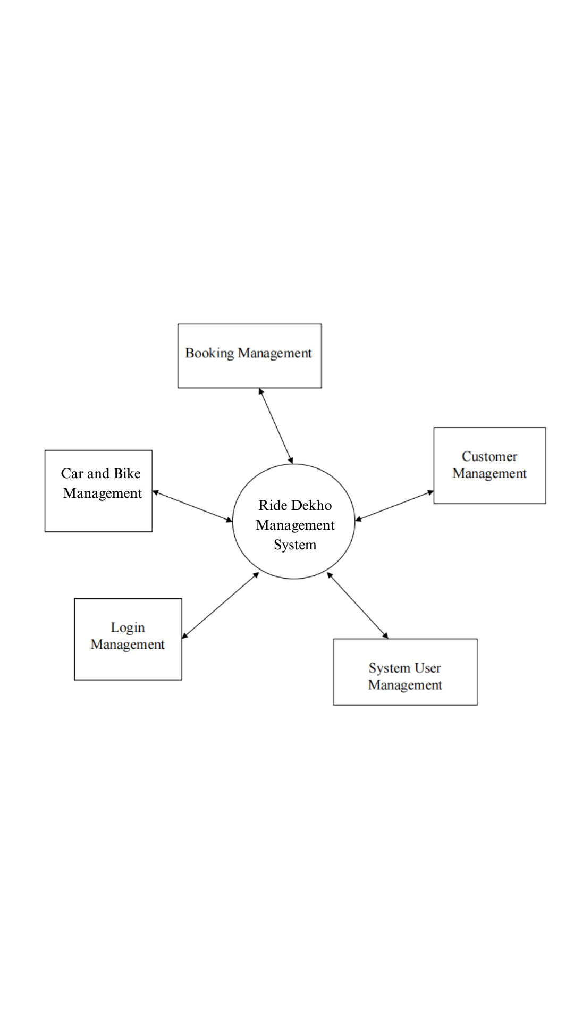

Figure 1: Zero level DFD

Zero Level DFD of online car and bike rental system, it elaborates high level process of

online car and bike rental system. It is an overview of the whole online car and bike rental system there are some high-level entities for the process of car and bike rental system.

**First Level Data Flow Diagram**

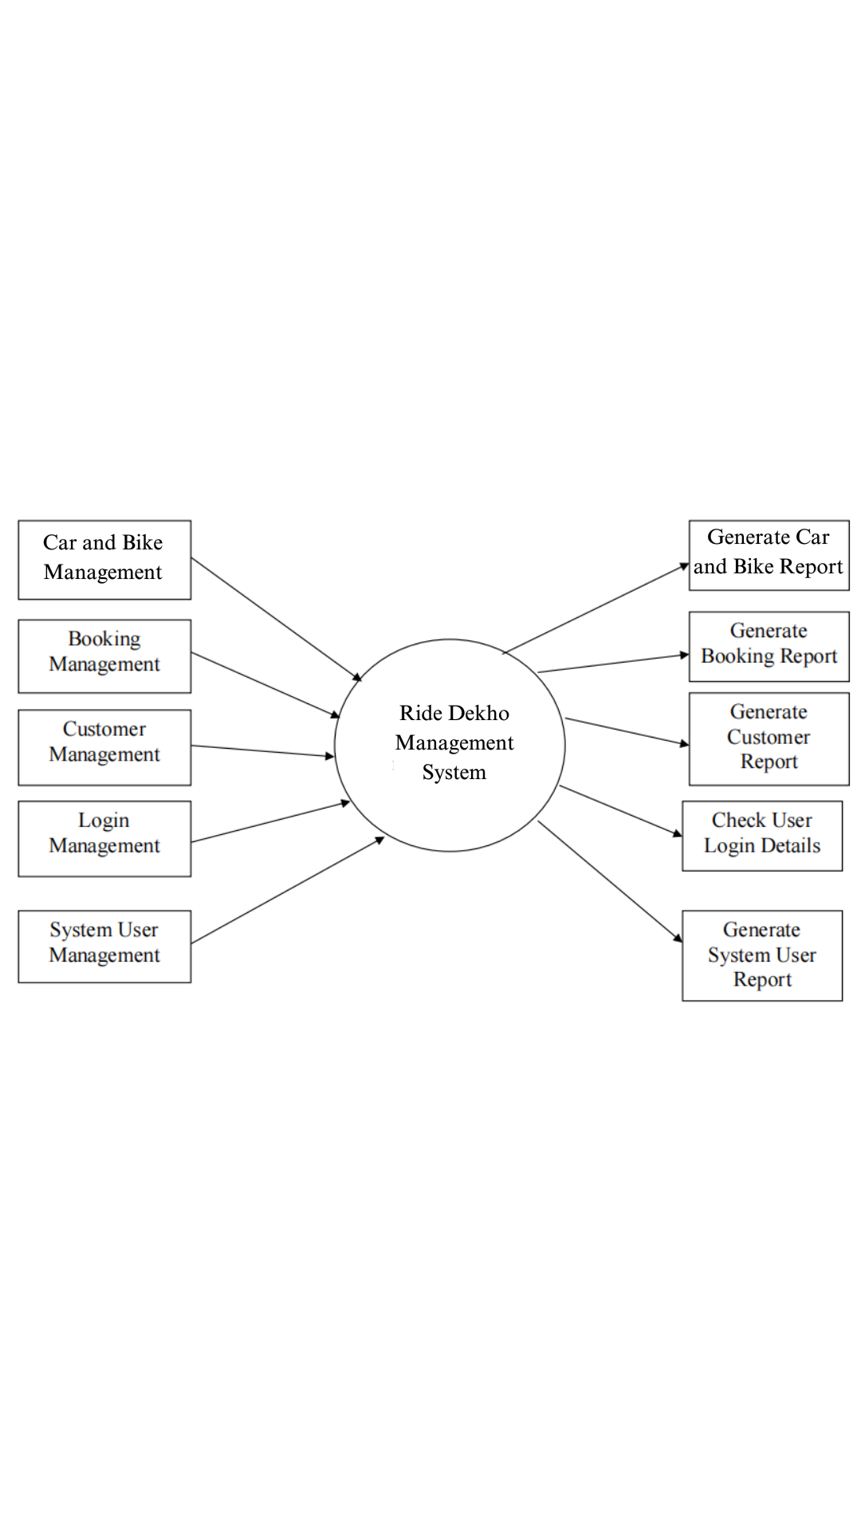

Figure 2: 1st level DFD

The 1st  Level DFD of the online RideDekho system shows how the system is divided into sub systems, each of which deals with one or more of the data that flows to or from an external agent, which together provides all the functionality of an online car and bike rental system as a whole, above are some given entities and the output of 1st level.

**Second Level Data Flow Diagram**

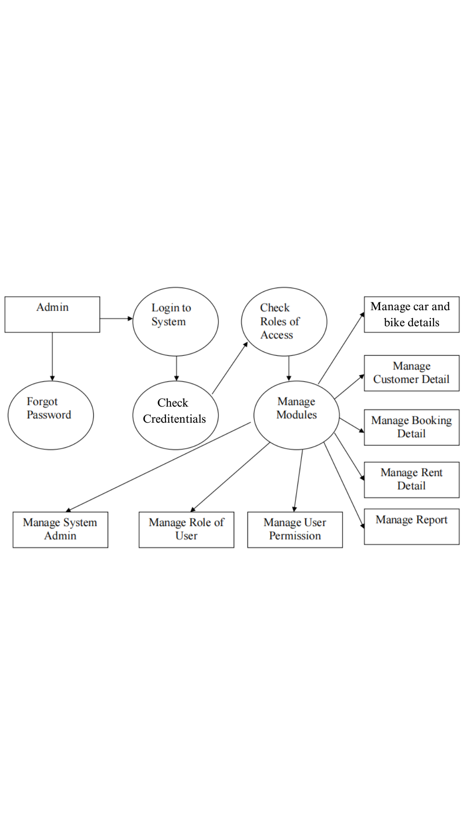

Figure 3: 2nd level DFD

**6.2 ER-DIAGRAM**

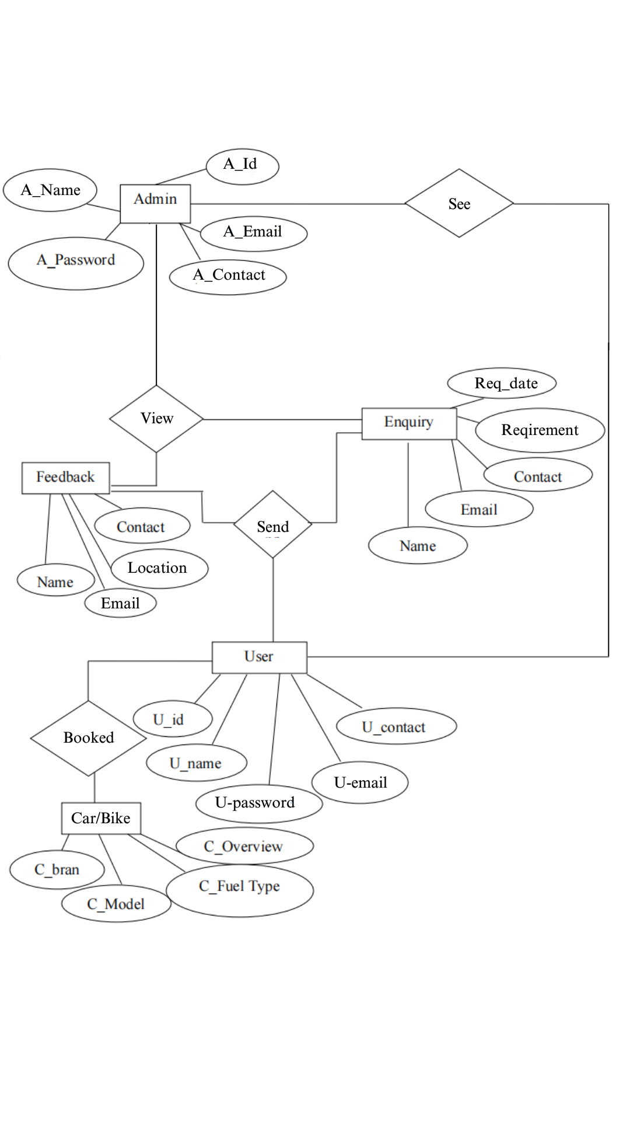

Figure 4: ER Diagram

**CHAPTER-7**

**USE CASE DIAGRAM**

**7.1 Use Case Description**

Actor and use case description shows the detailed description of the interaction between the actors and their use cases. The description enables us to have a proper understanding of how the actor interacts with the system through their use cases.

|  |  |  |
| --- | --- | --- |
| **Actor** | **Use-case** | **Use-case Description** |
| Register as member  Customer  Admin  Update car or bike details |  | This use case describes the activities of the customer to register online and become a member. Customer's details are required as part of the registration. Login details is  automatically sent to the customer after successful registration. |
| Booking  Reservation | This use case enables customers to search and make reservations. Non-registered customers will be directed to register before their reservation can be confirmed. A notification is automatically sent to the customer after the task is completed. |
| Return car or bike | This use case describes the event of a customer returning the car or the bike borrowed. The use case extends to "process rental" use case from the staff actor. |
| Give  feedback | This use case is used by the customer  to provide feedback/comment to the  company; a confirmation notification will be sent to the customer once a feedback has been submitted. |
| Add a new car | This use case is used by the staff to add new cars or bikes to the company's fleet database. Staff will need to login to activate this use case. |
|  | This use case is used by the staff to edit and modify car details whenever there is new renewal (insurance, road tax). It allows the company to keep an up-to-date record of their  fleet. |
| Reply to  customer’s  feedback | This use case describes the event by which staff updates the system when customers pick up or when they return their car or bike. |

Table 1: Actors and Use Case Description

**7.2 Use-case Login**

|  |  |  |
| --- | --- | --- |
| Use-case Number | UC-01 | |
| Use-case Name | Login | |
| Actor | Customer | |
| Description | This use case describes how the users login into this online Ride Dekho system | |
| Precondition | None | |
| Post condition | If the use case was successful, the actor is now logged into the application. | |
| Basic course of  Action | **User Action** | **System Response** |
| 1. The user is on the home page to  login to the system.  3.The user enters username and Password then click  on login button. | 2.The system promotes the user to  enter Username and Password.  4.The system verifies that all the information.  5.The system successfully logged in  6.Use case exit |

Table no-2: Use case -Login

**7.3 Use-case Booking Vehicle**

|  |  |  |
| --- | --- | --- |
| Use-case Number | UC-02 | |
| Use-case Name | Booking car or bike | |
| Description | This use case permits customers to book and make a schedule for renting a car or a bike, based on the availability. | |
| Precondition | A customer wants to book a car or a bike and reservation details about  customer has to be entered. | |
| Post condition | Customers booking successfully | |
| Basic course of  Action | **User Action** | **System Response** |
| 1. The customer wants to book a car or a bike.  2. The customer clicks on the booking page.  4. The customer enters the following information (customer's full name, email address, password, pickup date  & return date)  5. The customer clicks on booking button to book.  8. The customer accepts the  reservation and click Accept. | 3. The system prompts the  customer to fill out a reservation form.  6. The system checks all required  information had been filled in and the date entered dates are valid  7. The system presents information  to accept or decline the rental  Agreement.  9. The system shows the  customer that the reservation has  been completed, and presents the  customer a reservation confirmation  number.  10. Use case ends. |

Table No. 3: Use Case Booking Car or Bike

**7.4 Use Case View My booking**

|  |  |  |
| --- | --- | --- |
| Use-case Number | UC-03 | |
| Use-case Name | My Booking | |
| Actor | User | |
| Description | These use case allow staff to view or display customer reservations. | |
| Precondition | UC-1 | |
| Post condition | Display All Bookings | |
| Basic course of  Action | **User Action** | **System Response** |
| 1. The staff wants to view  reservation.  2. The staff requests the  reservation page.  4.Then on the reservation page  the employee clicks view  Button. | 3. The system responds the  requested page.  5. The system puts on view or  displays all reservation information  to the employee.  6. Use case ends. |

Table No.4: Use Case View My booking

**7.5 Use Case Diagram**

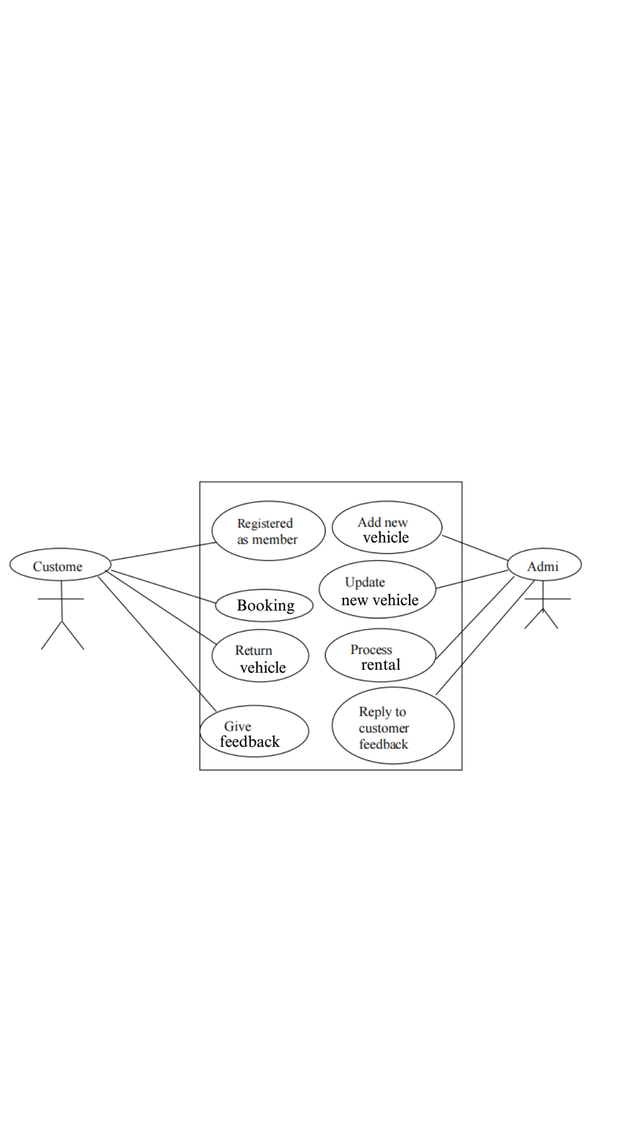Figure 5 : Online Car and Bike Rental System [use case]

**CHAPTER-8**

**OUTPUT/SCREENSHOT**

**8.1 Screenshot**

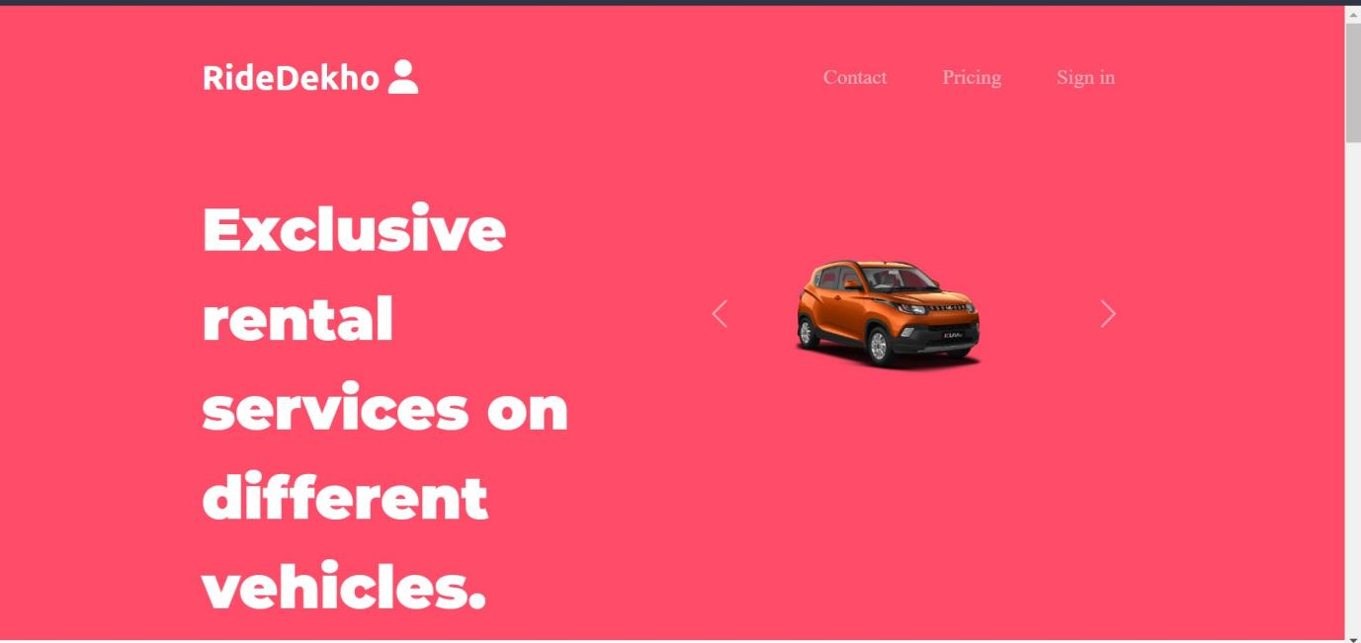

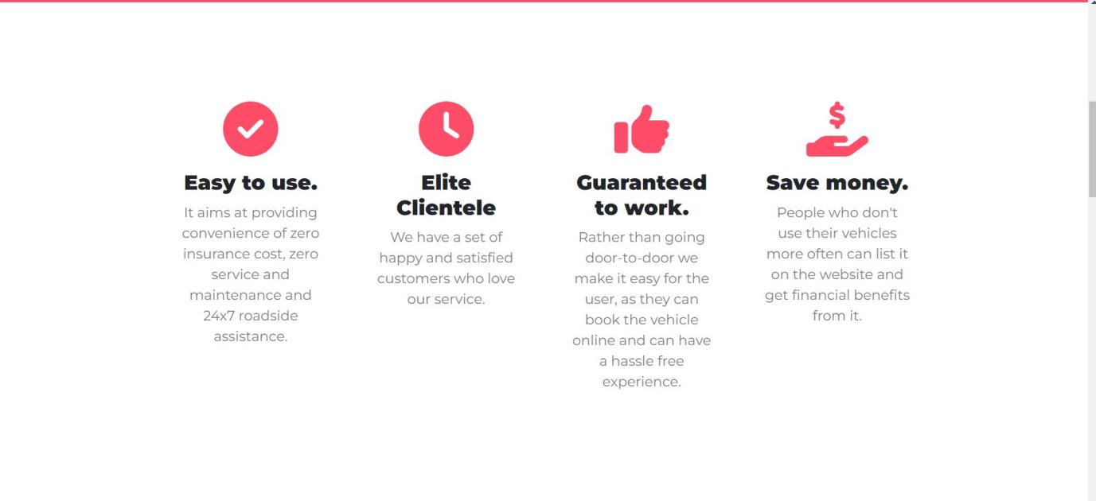

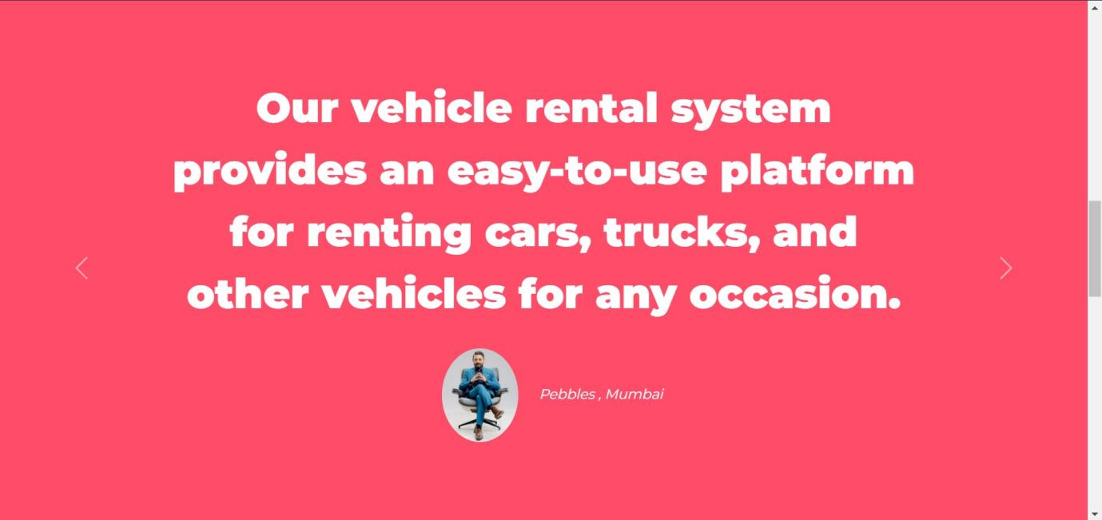

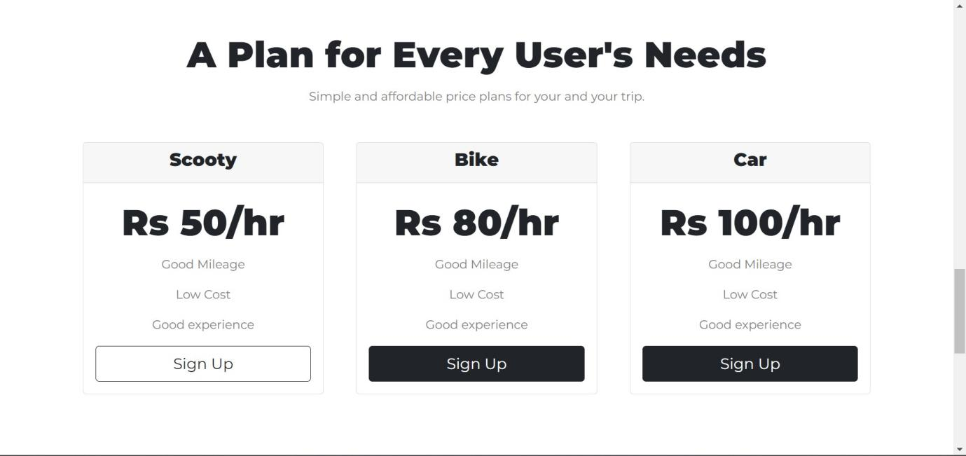

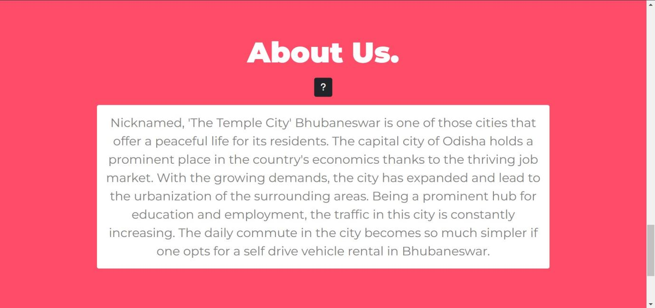

Figure 6: Home Page

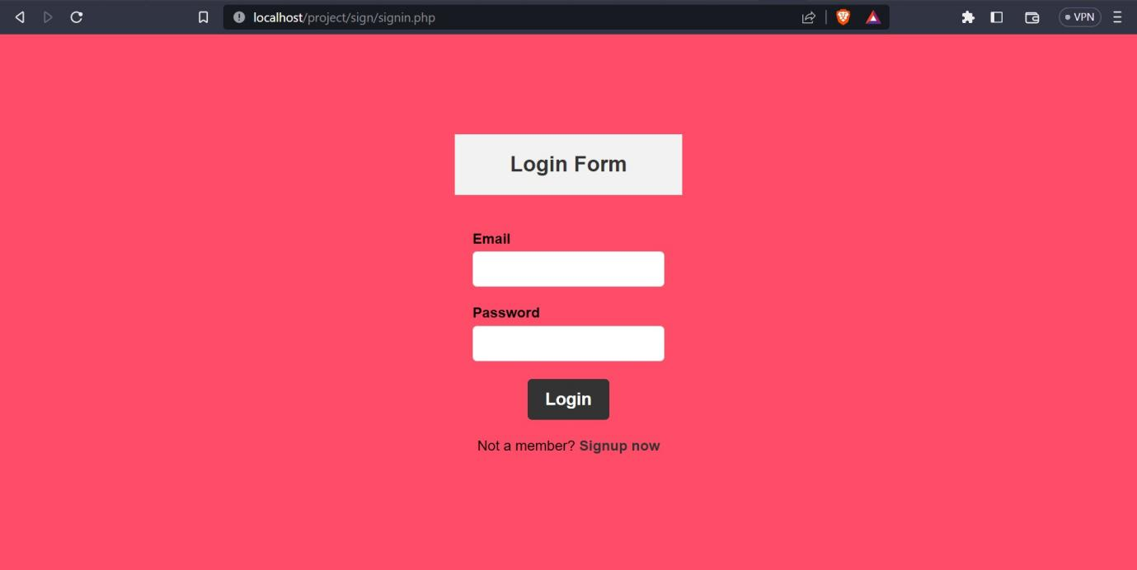

Figure 7: Login Page

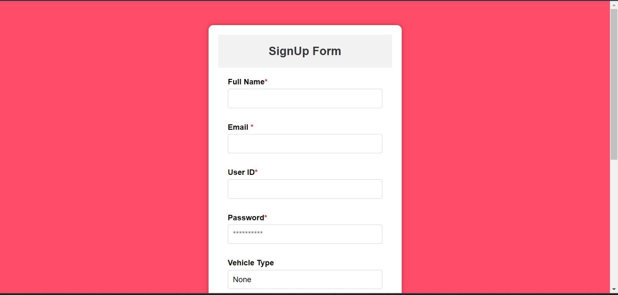

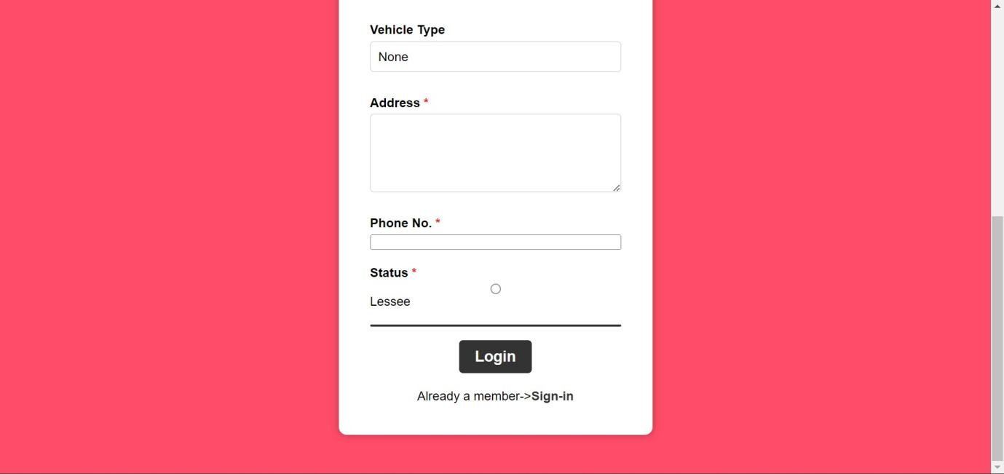

Figure 8: Sign-up Page

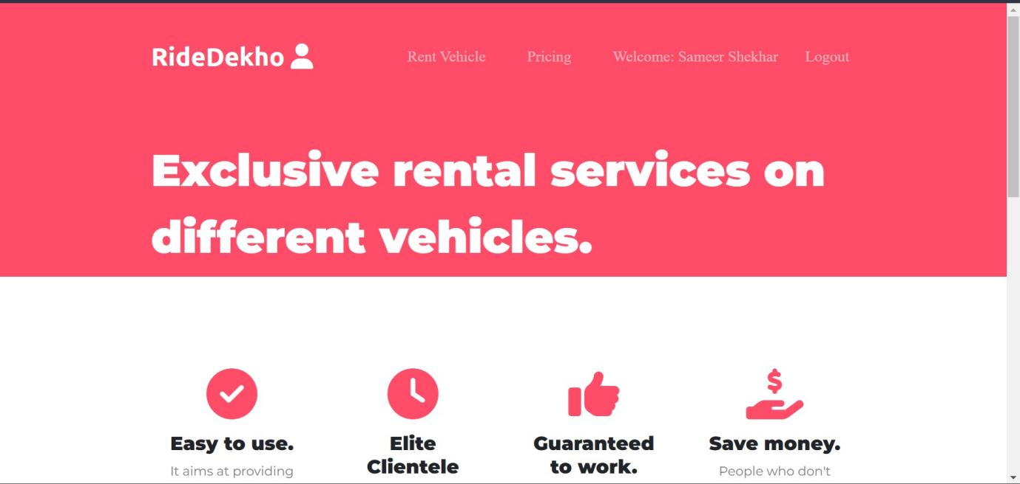

Figure 9: Dashboard

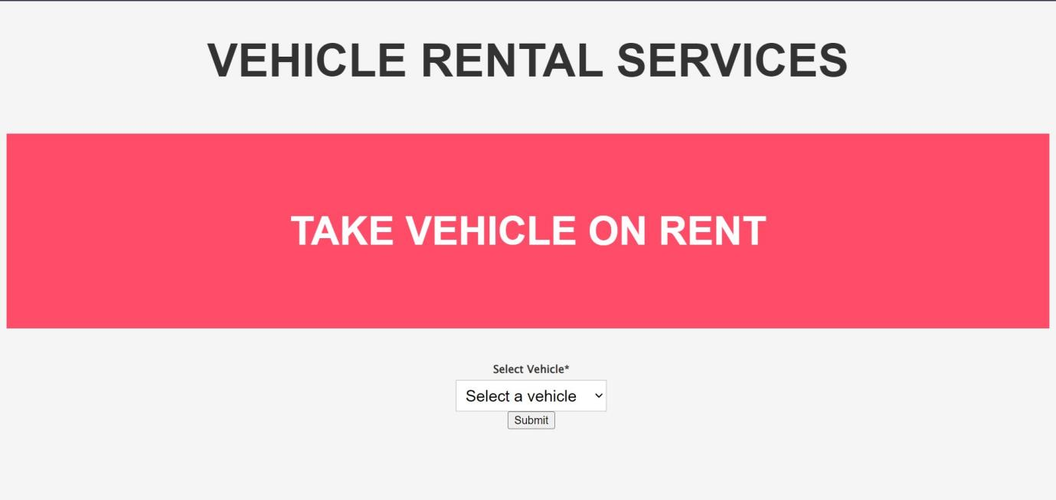



Figure 10: Booking Page

**8.2 Summary**

The user interface has been designed keeping in mind the guidelines for good and easy-to-learn interfaces. The interface provides proper guidance for operation, including success and error messages to keep the user aware of the results and operations. Tabular navigation panels have been used to provide links to commonly accessible tasks, and proper menus and sub-menus have been implemented wherever required for effective navigation.

**CHAPTER-9**

**CONCLUSION AND SCOPE OF FUTURE WORK**

**9.1 Conclusion**

The car and bike rental business has emerged with a new goodies compared to the past experience where every activity concerning car and bike rental business is limited to a physical location only. Even though the physical location has not been totally eradicated; the nature of functions and how these functions are achieved has been reshaped by the power of the internet. Nowadays, customers can book cars and bikes online, rent them online, and have the vehicle brought to their door once the customer is a registered member or goes to the office to pick up the car. The web based car and bike rental system has offered an advantage to both customers as well as the rental company, to efficiently and effectively manage the business and satisfy customers’ needs at the click of a button.

**9.2 Future Enhancement**

In near future, we are planning to hire cars daily bases. So that clients can give

their car to the customer on daily bases. We are planning to add new feature i.e.

pay after the trip. We are working to increase automation in the system to increase user experience great.

**CHAPTER-10**

**BIBLIOGRAPHY AND REFERENCES**

**Books Used:**

• Software Engineering - R.S. Pressman

• PHP For Dummies

• PHP Beginners Guide By McGrawhill Publication

• Javascript By McGrawhill Publication

**References Used:**

• http://www.carrentingsolutions.com/

• http://www.flashvortex.com/

• http://www.imscart.com/car_rental_software.html

• Wikipedia.org

• www.w3schools.com

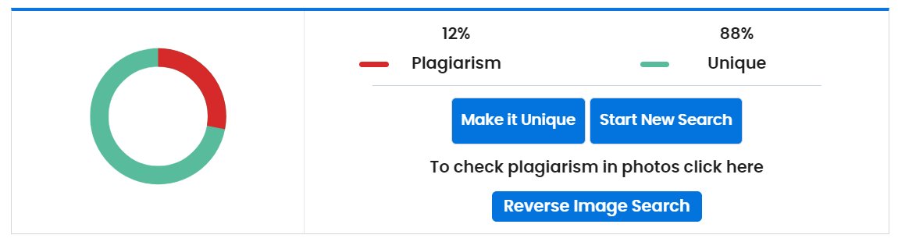**Plagiarism Check Report**